**PROJECT REPORT ON AI-POWERED HOURLY ATTENDANCE SYSTEM**

**INTRODUCTION**:

Capturing attendance is essential in all the organisations for checking presence of every student or employees. It is facilitated to access the performance and information of attendance of a particular Student in a particular semester of study. The information is sorted by the teachers, instructors and advisors, as provided by the student for a particular day throughout a complete semester. This system will also enable the evaluation of student regular presence in various lectures which will determine the eligibility of the student to sit for a semester examination.

**PURPOSE:**

The proposed system is designed for automating the attendance of different organisations and reduces the flaws of existing manual systems. The system calculates the attendance of each student on an hourly basis and displays the attendance for each one of them.

**EXISTING PROBLEM:**

Maintaining attendance is very important in all the institutes for checking the attendance percentage of Students. Every institute has its own method in this regard. Some are taking attendance manually on the register for every hour and later they will upload every hour data of a class to the server or file-based approach and some have adopted methods of automatic attendance using some biometric techniques. But these methods are inefficient and time-consuming, AI can definitely find a solution to this problem.

**PROPOSED SOLUTION:**

The proposed solution/application shall capture hourly attendance without any manual intervention. develop a smart device that can be integrated with a camera that will capture the images of class for every hour and send the images to model.  Then the model will use AWS Rekognition Service to recognize the student’s faces & push the images to S3(Simple Storage Service) for storage and also updates the attendance automatically in a database. build a web-based dashboard to visualize all the student’s attendance information.

**BLOCK DIAGRAM:**

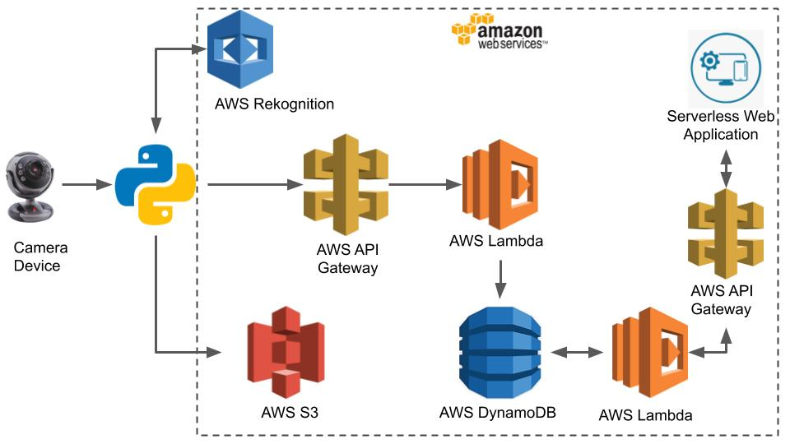

**SOFTWARE DESIGNING:**

* Store the Images of Students in S3 Bucket
* Capture the image on an Hourly basis
* Load the image to Face comparison algorithm (compares the faces in s3 bucket)
* Mark the attendance for compared faces and store in DynamoDb
* Create a rest API using API gateway and lambda function to connect to dynamo DB through web app
* Create a web-based dashboard to visualize the attendance

**ADVANTAGES:**

* Cost effective
* Secure
* Time saving
* Easy to manage

**DISADVANTAGES:**

* Low reliability
* Data Breach

**APPLICATIONS:**

* Contactless Biometric system
* Airport security
* In warehouses to control entry and exit of vehicles.

**CONCLUSION:**

The system decreases the error while taking attendance count manually. Using Artificial Intelligence, we can make the system more reliable, easy to use and saves time of teachers, students and the employees in the organisations too.